2024 STEFFI NOSSEN ANNUAL CONCERT
“A Dancer’s Collage”
Inspired by Eric Carle

Sunday, May 19th

~ IMPORTANT CONCERT INFORMATION ~
Regarding Core Classes Performing in 4PM Annual Concert
Monday 4:45pm Modern II- Courtney
Thursday 5pm Jazz II/III- Alexandra
Thursday 6pm Beg Preteen Jazz- Alexandra
Saturday 10:15am Ballet I - Courtney
Saturday 11:15am Ballet II/III - Courtney
Saturday 9am Ballet IV - Courtney
Saturday 9am Modern I – Caren
Saturday 10am Modern II/III- Caren
Saturday 11am Modern IV - Caren

Dress Rehearsal: Saturday, May 18th
Dancers Arrive - 2:15pm
Dancer Pick-Up - 5:50pm

Performance: Sunday, May 19th
Dancers Arrive - 3:15pm
House Opens - 3:30pm
Performance Begins - 4:00pm

Dress Rehearsal & Performance Location
White Plains High School Auditorium
550 North St, White Plains, NY 10605 (enter on Bryant Ave.)

IMPORTANT CONCERT INFORMATION

Please read the following information CAREFULLY & SAVE for future reference.
We are so happy to have your dancer performing in our 2024 Annual Concert. All dancers are required to be at the Dress Rehearsal and the Concert for the entire time to ensure that the performance runs smoothly. This is an important part of their dance education and helps us provide the best performance we can!
COSTUMES
Costumes will be at the theater ready for the dancer’s Dress Rehearsal and Performance. ALL core classes will be allowed to take their costumes home AFTER THE PERFORMANCE ON SUNDAY.

You MUST bring your child’s listed shoes to the Dress Rehearsal and the Performance:

BALLET I - pink ballet shoes
BALLET II/III - pink ballet shoes
BALLET IV - black ballet shoes
TAP II/III- black tap shoes
JAZZ- black jazz shoes

MAKE UP & HAIR
Hair must be neatly pulled back into a bun for all Ballet classes and a ponytail for all Modern classes, with no “whispies”. Teachers will tell parents about specific hairstyles, if any are required. Make-up is only required for Sunday’s performance. The dancers must come to the theatre with make-up already applied (lipstick, blush and eye shadow in soft colors) and hair done. We suggest that you bring extra hair elastics, bobby pins, hair nets, hair spray just in case. NEW***For stage makeup tips and tutorials, check out our website or our Instagram!!!!

DRESS REHEARSAL ATTENDANCE and DISMISSAL
The Dress Rehearsal process is VERY important. We put all elements of the performance together at this time; lighting, costumes, spacing, choreography and music. We run as close to schedule as possible. We want the dancers to feel confident on stage during their dances and familiar with the backstage areas. Families are NOT allowed to watch the dress rehearsal unless they are assisting faculty or have permission from the Director.
Attendance is MANDATORY and NO students may leave until Dismissal.

PERFORMANCE
Dancers will be supervised by faculty, parent volunteers, and student assistants backstage. At the end of the performance, you can pick your dancer up at the check-in desk in the lobby.

BACK-STAGE VOLUNTEERS
We need a few Back-Stage Parents to help during the Dress Rehearsal on Saturday, May 18th and the performance on Sunday, May 19th. Please email tara@steffinossen.org if you would like to volunteer! Note: you will not be able to see the performance that you volunteer for… but you can watch your dancer’s piece from backstage only.

TICKETS
Tickets will go on sale on April 22nd
They will be sold online- (credit card only) at www.steffinossen.org/annual-concert-2024/
Note- this year, through our new online ticket system, Zeffy, there are no additional fees!
OR you may fill out and return the form at the back of this packet (cash or check) to the office.
Adult: $35.00 Child / Senior: $25.00
Seating is General Admission.

NEW****FLOWER BOUQUET/ COMMEMORATIVE T SHIRT PRE ORDERS
For your convenience, when you order your tickets, we are offering the option to preorder flowers and/or a special annual concert t shirt for your performer that you can pick up the day of the show!!
Important- these presale items are only available to order until May 6th. No flowers or t shirts will be sold at the concert, so please plan accordingly!

STAFF FLOWERS
It is our tradition to present flowers to the teachers & staff at the final bow. Families may contribute to these bouquets if they wish. There will be a box available in the office for your donation, $5 is a typical donation.

If you have any questions, please do not hesitate to contact the office at 914-328-1900, or email Tara LeVoci at tara@steffinossen.org
Thank you for your commitment and consideration in this exciting time of year!
Tara LeVoci, School Coordinator
Steffi Nossen School of Dance

ORDER FORM – 2024 ANNUAL CONCERT
 TICKETS may be ordered with this form and picked up at the office.
Tickets are $35 for Adults and $25 for Seniors & Children.
Purchase via the form below OR online (credit card) at: www.steffinossen.org/annual-concert-2024/
******************************************************************************************************

For tickets, please circle the show you are attending. If you are purchasing tickets for both shows, please note your request.
Circle the show: 1:00pm OR 4:00pm
#_____ TICKETS @ $35 for Adults = _____ #_______ TICKETS Children Under 3 FREE
#_____ TICKETS @ $25 for Seniors & Children = _____
Orders must be submitted by May 6th. No flowers or t-shirts will be sold at the door.

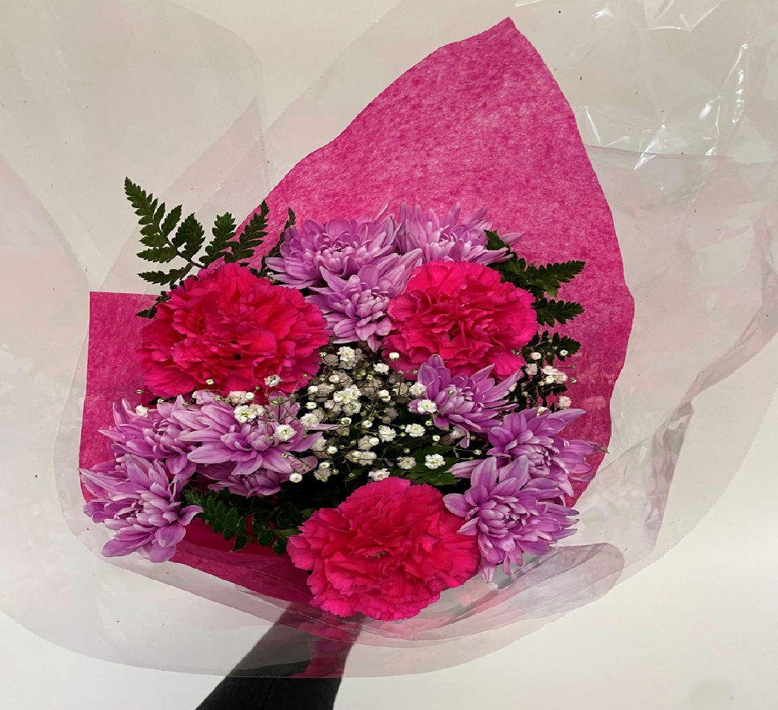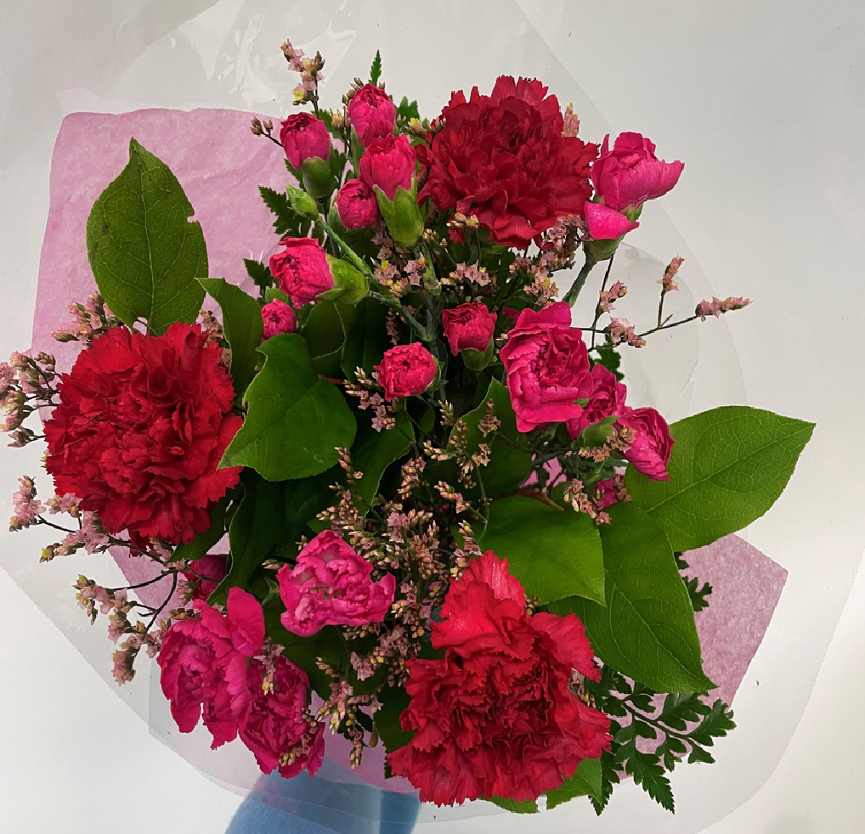
☐$25 Small pink/purple ☐$25 Small colorful ☐$30 Med pink/purple ☐$30 Med colorful

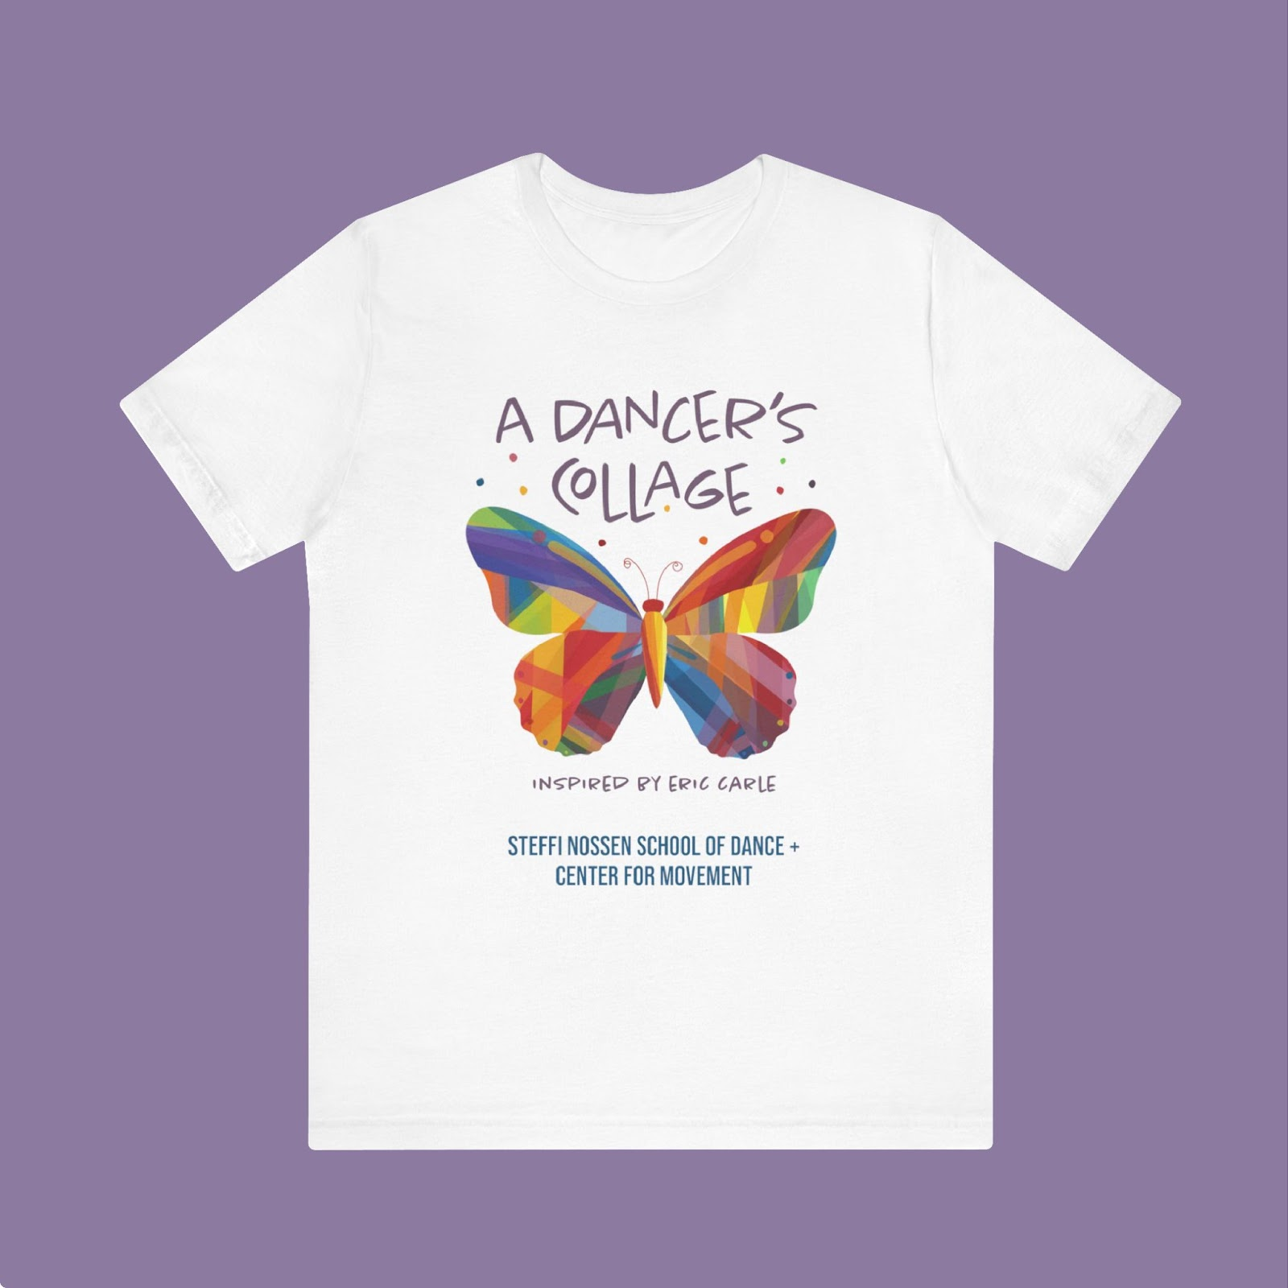
☐$40 Large pink/purple ☐$40 Large colorful ☐$45 Sizes-Ch: Sm, Med, & Lg & Adult: Sm, Med, & Lg

TOTAL AMOUNT ENCLOSED _________________ T-Shirt Size(s) _________________

YOUR NAME:____________________________ CHILD’S NAME:__________________________________________

PHONE #:_____________________________ EMAIL:_________________________________________

Make checks payable to: Steffi Nossen School of Dance
Please send your form and check to: Steffi Nossen School of Dance 216 Central Ave., White Plains, NY 10606

