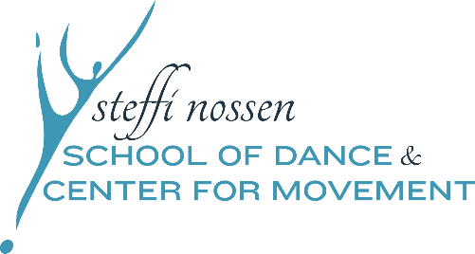

2024 CHILDREN’S CONCERT

We are so excited for your young dancer to be participating in our Annual Children’s Concert, Sunday, April 28th. This letter provides all the details of the day, so please read closely!
Sunday, April 28th 1pm Children’s Concert
Performed in the Recital Hall at the Music Conservatory of Westchester
Includes
Monday 4:00pm Creative Movement (Chappaqua)
Tuesday 3:45pm Creative Movement
Friday 4:00pm Ballet/Tap
Saturday 12:15pm Creative Movement
DRESS REHEARSAL
Sunday, April 28th ~ All dancers must arrive no later than 11:15am.
Check in will be in the main lobby of the Conservatory. All dancers must sign-in.
Parents will not be allowed to stay during the dress rehearsal. This will help your child focus on their choreography and keep the big dance a secret, so feel free to take that time to relax before the show.

WHAT TO WEAR
-All female identifying Creative Movement dancers should wear their pink cap sleeve leotard (no skirts attached or embellishments on leotard) and white footless tights.*
-All female identifying Ballet & Tap dancers should wear their pink cap sleeve leotard (no skirt attached or embellishments on leotard), pink footed tights and black tap shoes.*
*Leotard and tights can be purchased in office if needed.
-Costume and hat will be given to the dancers once they arrive.
-Hair must be pulled back neatly away from face with no whispies, either in ponytail, braid, or halfway back if they have short hair.
-All male identifying dancers should wear black pants and will be given colorful shirts and hats when they arrive.

TICKETS
$10 Adult Tickets
$5 Senior & Student Tickets
Kids under 3 Free!
-We have a limited number of seats available due to the capacity of the theater. Each family will be able to purchase 4 tickets ONLY. All children 3 & under will not need a ticket but will need to sit on a lap, they will not be permitted to sit on a chair as we will need all chairs for ticketed audience members. PLEASE LET US KNOW IF YOU HAVE A CHILD UNDER 3 THAT WILL BE ATTENDING. If you need extra tickets, please contact the office to be put on our ticket waitlist.
-Tickets will go on sale on Monday, April 1st in the office, CASH or CHECK only. Please purchase tickets in advance, we will not be selling tickets at the door.
-Flower Bouquet Pre-sale also available. For your convenience, pick up pre-ordered flowers for your dancer in the lobby just before the show! Note: we will not be selling flowers at the door.
PICK UP AFTER THE SHOW
-All dancers will be waiting for you after the show in Studio A downstairs. Please have only 1 parent come down to pick up.
Dancers will NOT be allowed to leave before the show is finished.
VIDEOGRAPHY
-We will have a professional videographer at the performance. We will send you a link to the free digital download after the show to share with all your loved ones.
REMINDER!
There are still classes after the show! Classes will continue until June 3rd, 2024, and teachers will be preparing the dancers for the next year’s curriculum!
NEW! CRAYON DRIVE!
Steffi Nossen’s crayon drive is open! Please bring us your well- loved broken crayons, which will be recycled into new fresh crayons to be distributed at children’s hospitals through The Crayon Initiative. We have a collection container in the office, or you may give your bagged crayons to your teacher to give to us!
Please email School Coordinator, Tara LeVoci at tara@steffinossen.org with any questions or concerns!
Looking forward to seeing your dancer color the stage with their creativity.

Warmly,
Tara LeVoci
School Coordinator

