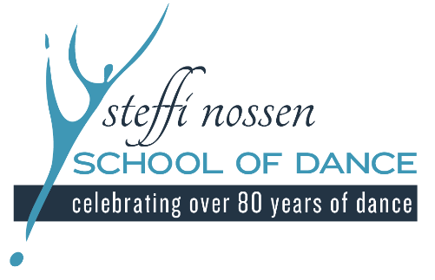

2022 CHILDREN’S CONCERT

We are so excited for your young dancer to be participating in our Annual Children’s Concert, Sunday, May 1st. This letter provides all of the details of the day, so please read closely!
Sunday, May 1st 1pm Children’s Concert
Performed in the Recital Hall at the Music Conservatory of Westchester
Includes;
Monday 4:00pm Creative Movement (Chappaqua)
Tuesday 3:45pm Creative Movement
Thursday 10:30am Creative Movement
Friday 4:00pm Ballet/Tap
Saturday 12:00pm Ballet/Tap
DRESS REHEARSAL
Sunday, May 1st ~ All dancers must arrive no later than 11:15am.
Check in will be in the main lobby of the Conservatory. All dancers must sign-in.
Parents will not be allowed to stay during the dress rehearsal. This will help your child focus on their choreography and keep the big dance a secret, so feel free to take that time to relax before the show.

WHAT TO WEAR
-All female Creative Movement dancers should wear their pink cap sleeve leotard (no skirts attached or embellishments on leotard) and white footless tights.
-All female Ballet & Tap dancers should wear their pink cap sleeve leotard (no skirt attached or embellishments on leotard), pink footed tights and black tap shoes.
*Leotard and tights can be purchased in office if needed
-Tutu’s and hair accessory will be given to the dancers once they arrive.
-Hair must be pulled back neatly away from face with no whispies. Either in ponytail, braid or halfway back if they have short hair.
-All male dancers should wear black pants and will be given colorful shirts and suspenders when they arrive.

TICKETS
$10 Adult Tickets
$5 Senior Tickets
Kids under 3 Free!
-We have a limited number of seats available due to the capacity of the theater and COVID protocols by the Music Conservatory. Each family will be able to purchase 2 tickets ONLY. All children 3 & under will not need a ticket but will need to sit on a lap, they will not be permitted to sit on a chair as we will need all chairs for ticketed audience members. PLEASE LET US KNOW IF YOU HAVE A CHILD UNDER 3 THAT WILL BE ATTENDING.
-Tickets will go on sale on Monday, April 18th in the office, CASH or CHECK only. Please purchase tickets in advanced, we will not be selling tickets at the door.

PICK UP AFTER THE SHOW
-All dancers will be waiting for you after the show in Studio A downstairs. Please have only 1 parent come down to pick up.
Dancers will NOT be allowed to leave before the show is finished.

VIDEOGRAPY
-We will have a professional videographer at the performance. We will send you a link to the free digital download after the show to share with all of your loved ones.

REMINDER!
There are still classes after the show! Classes will continue until June 2nd, 2022, and teachers will be preparing the dancers for the next year curriculum!

Please email School Director, Kristina Todd Nelson at kristina@steffinossen.org for any questions or concerns!

Looking forward to seeing your dancer spin, twirl and shine on stage.

Warmly,
Kristina Todd Nelson
School Directors

